Method extension of CIPAC 333/LN

Determination of deltamethrin in PE by high performance liquid chromatography

1. Sampling

The samples should be taken approximately according to the Manual on the Development and Use of FAO and WHO specifications for Pesticides which is shown in Figure 1 and the sampling is at position 5. Sub sampling by 1 piece of size 30cm x 30 cm. Sample may be cut into 1-2 cm squares and thoroughly mixed. Sample shall be separately packed in aluminium foil and kept out of direct sunlight at room temperature or lower.

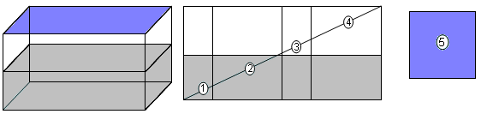

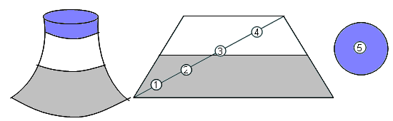

Figure 1: Sub sampling from a bed net as per the Manual on the Development and Use of FAO and WHO specifications for Pesticides

2. Identity test
HPLC. As for deltamethrin long lasting insecticidal nets CIPAC 333/LN.

3. Deltamethrin. As for deltamethrin long lasting insectidal nets CIPAC 333/LN, except calibration solution (REAGENTS), preparation of sample and determination (PROCEDURE)

OUTLINE OF METHOD. The sample is extracted by refluxing with xylene. The extracted solution is evaporated and reconstituted in mobile phase (MP). The deltamethrin content is determined by normal phase high performance liquid chromatography using dibutyl phthalate as internal standard and detection at 254 nm.

REAGENTS. As for deltamethrin long lasting insectidal nets CIPAC 333/LN, except

- Xylene .
- Internal standard solution (IS): 2.0 mg/ml of dibutyl phthalate in MP.
- Deltamethrin standard solution 2.4 mg/ml (DS): weigh 0.06 g (to the nearest of 0.01 mg) of deltamethrin neat standard, quantitatively transfer to 50 volumetric flask, dissolved completely with MP, keep regulated by waterbath at 20ºC, fill up to the mark with MP.

APPARATUS As for deltamethrin long lasting insecticidal nets CIPAC 333/LN, except

- Magnetic stirring hot plate.
- Laboratory reflux apparatus.

PROCEDURE
(a) Operating conditions As for deltamethrin long lasting insecticidal nets CIPAC 333/LN, except
- Wavelength at 254 nm.
- IS amount of 4mg is used instead of 2 mg.
(b) Preparation of calibration curve:
Into a series of clean 20 ml PTFE liner screw cap vials, add accordingly as table below. Filter through 0.45 µm syringe filter before use.
Code | IS  (ml) | DS  (ml) | MP  (ml) | DM  (mg) | Total volume (ml)
C1 | 2.00 | 0.3 | 17.7 | 0.60 | 20
C2 | 2.00 | 0.4 | 17.6 | 0.84 | 20
C3 | 2.00 | 0.5 | 17.5 | 1.08 | 20
C4 | 2.00 | 0.6 | 17.4 | 1.32 | 20
C5 | 2.00 | 0.7 | 17.3 | 1.56 | 20

(c) Preparation of sample.
Weigh (to the nearest 0.1 mg) 0.3 g of the sample into a reflux flask. Add 18 ml xylene and 2 ml IS of solution. Heat up to reflux during 30 minutes under stirring. Cool down to room temperature. Filter the extracted solution through a 0.45 μm filter membrane. 0.5 ml of the filtered solution is dried under nitrogen stream and reconstituted in 0.5 ml of MP.
(d) Determination. Inject sample solution into HPLC system

(e) Calculation. As for deltamethrin long lasting insecticidal nets CIPAC 333,LN

